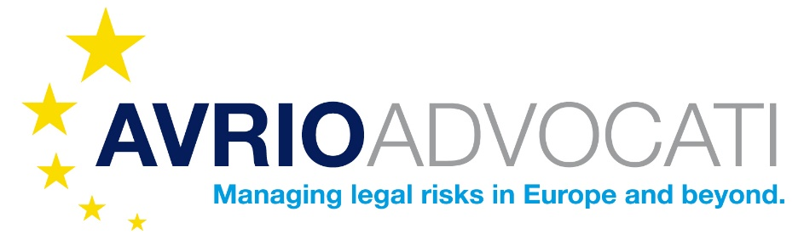

What is the Avrio Advocati Exchange Programme?
The Avrio Advocati Exchange Programme is a distinguished initiative that facilitates short-term placements for lawyers within our extensive network of member firms across the globe. Whether you’re looking to learn about different legal systems, share knowledge, or build lasting professional relationships, this programme is designed to enhance your career and personal development.

Why Participate?
1. Global Perspective:
- Experience different legal practices and cultures.
- Gain insights into international legal systems and regulations.
- Enhance your ability to work on cross-border cases.
2. Professional Growth:
- Develop new skills and deepen your legal expertise.
- Observe high-quality work in other leading law firms.
- Boost your firm’s resume with international experience.
3. Networking Opportunities:
- Forge connections with top legal professionals worldwide.
- Build a global network that can support your career for years to come.
- Share and exchange knowledge with peers from diverse legal backgrounds.

Who Can Apply?
- Experienced Lawyers in Member Firms: Deepen your understanding of international legal systems and broaden your practice areas.
- Early Career Lawyers in Member Firms: Jumpstart your career with invaluable international exposure and hands-on experience.

Who Pays?
The firm sending a lawyer on exchange will pay for the salary and accommodation of the exchanged lawyer. The host firm will provide details about local accommodation and transportation to help you decide on a place to stay.
What Work Do They Do?
It is preferrable that the visiting lawyer has experience in the areas of law the host firm works in. However it is not essential and in some cases, the exchanged lawyer may continue to carry out work with their home firm. This should be agreed between the two firms in advance.
How Long is The Stay?
The length of the visit should be agreed between the exchange lawyer and two firms in advance. Exchanges are usually for a period of one or two weeks but may last longer if all parties agree.
Where Are Exchange Opportunities Available?
The firms listed below are offering to host an exchange lawyer in 2024-25:
- Sarailis Avocats, Quebec City, Canada
- Caldwell & Robinson Solicitors, Dublin | Belfast | Derry, Ireland
- PC Law – Papadakis Čabarkapa, Belgrade
- Eimer Heuschmid Mehle, Bonn, Germany
If you would like to be placed with another member firm, please let us know and we will ask for you.

How to Get Started?
- Express Your Interest: Contact your firm's Avrio Advocati representative or email us directly at info@avrioadvocati.com.
- Choose Your Destination: Select from a range of member firms located in major cities around the world - https://www.avrioadvocati.com/directory
- Plan Your Placement: Work with us to tailor your exchange experience to align with your professional goals.

Testimonials
“Participating in the Avrio Advocati Exchange Programme was a transformative experience. It allowed me to gain a deeper understanding of international family and corporate law in a common law jurisdiction (I work in a civil law jurisdiction), share knowledge related to managing our own law firm and build connections that have been invaluable to my career. I’m looking forward to repeating this experience in another jurisdiction.”
— Ana Rita Relogio, CSA Sociedade de Advogados, Portugal
“Being a part of this programme gave me the chance to work in Caldwell & Robinson Solicitors, Londonderry, Northern Ireland and understand the intricacies of common law and European law. It’s an experience I highly recommend to any young lawyer looking to make their mark.”
— Nikita Zatler, Gorjup Law, Slovenia

Join Us and Broaden Your Legal Career
For more information or to apply, visit our website at www.avrioadvocati.com/lawyer-exchange-programme/or contact us at info@avrioadvocati.com.

This programme is open to all lawyers affiliated with Avrio Advocati member firms.

